PATIENT MONITORING USING GSM AND RF FOR HOSPITAL AND ADULT HOMES

Abstract:
The project utilizes the VB as the back end, with the help of KEIL C based device driver. While the embedded system as the front-end of the project. Thus the project is firmware based. This project allows a person to monitor the status of a patient, which is otherwise called as biometric monitoring; via the system. The parameters examined are the temperature, heartbeat and the pressure is monitored by use of (real time monolithic sensor), since the real time monitors are significantly much costly, the temperature or heartbeat or any other pressure quantity which is to be measured is fed to the analog to digital converter which is measured by means of its corresponding sensors for e.g.: temperature – LM35 (real time monolithic sensor), pressure –pressure transducer (real time monolithic sensor), heart rate – heart rate monitors available in markets (real time monolithic sensor).

The output from these sensors is fed to a multi channel analog to digital converters. This has multiplexed selection of data thus thereby selecting the required input at once. The output of ADC is 8 bit binary data the microcontroller reads the data and then displays in LCD and also provides the respective codes for the printer port there by instructing co running dynamic link library files to read the respective data from parallel port, which is designed with the help of Keil C for further communication with VB.

The corresponding parameters are then displayed on the system via the proper user experience interfacing with the LAN; the project is used to send SMS the status of a person. Such as heartbeat and temperature to the mobile number specified; the heart of the project is the AT89c52 controller. The microcontroller and whenever the safe ranges is violated the controller produces a alarm, and visual display, as well as initiates the pc, and data is transmitted by and received the data in receiver section displayed in LCD section and transmitted to serial port to PC, as well as send the SMS to a specified mobile number using a mobile phone which is interfaced with the pc.
Block Diagram :

Transmitter Section :

Multi Channel
ADC

ATMEL
89C51
Micro
Controller
Zigbee transceiver

Power Supply
Temp
Pre
Heart Beat

LCD

Receiver Section :

ATMEL
89C51
Micro
Controller

Serial Port
Zigbee transceiver
GSM
Modem

Power Supply

Alarm
Serial Port

Personal
Computer
System
VB
USB

Hardware Requirements :
- Microcontroller.
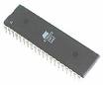
- RF Transmitter.
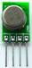
- RF Receiver.
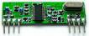
- GSM Modem.
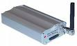
- ADC Unit.
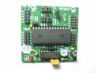
- LCD.
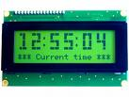
- Heart Beat Sensor.

- PC.


- Power Supply.
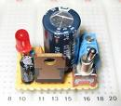
- Buzzer.
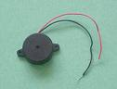

Software Requirements :
- Embedded C Programming.
- Keil Programmer.
- VB 6.0.

